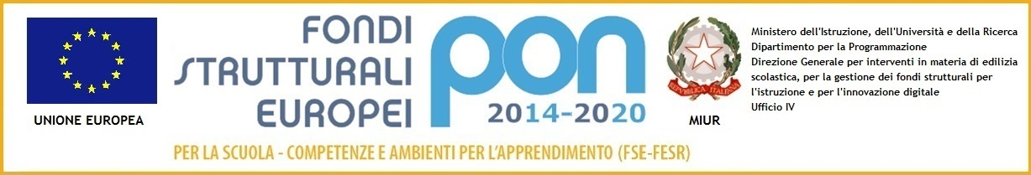

ISTITUTO COMPRENSIVO “VIRGILIO”
VIA VIRGILIO, 7 - 53040, ACQUAVIVA DI MONTEPULCIANO (SIENA)
Codice meccanografico: SIIC82000A – Codice Fiscale 90023330526
e-mail: siic82000a@istruzione.it
Sito web: www.istitutocomprensivovirgilio.gov.it

RELAZIONE FINALE DELL’ALUNNO___________________________________________

________________________________________________________________________________________________________________________________________________________________________________________________________________________________________________________________________________________________________________________________________________________________________________________________________________________________________________________________________________________________________________________________________________________________________________________________________________________________________________________________________________________________________________________________________________________________________________________________________________________________________________________________________________________________________________________________________________________________________________________________________________________________________________________________________________________________________________________________________________________________________________________________________________________________________________________________________________________________________________________________________________________________________________________________________________

FIRMA DEI PRESENTI
_____________________________________
_____________________________________

_____________________________________
_____________________________________

